H960

Hanes

50/50 Sport Shirt

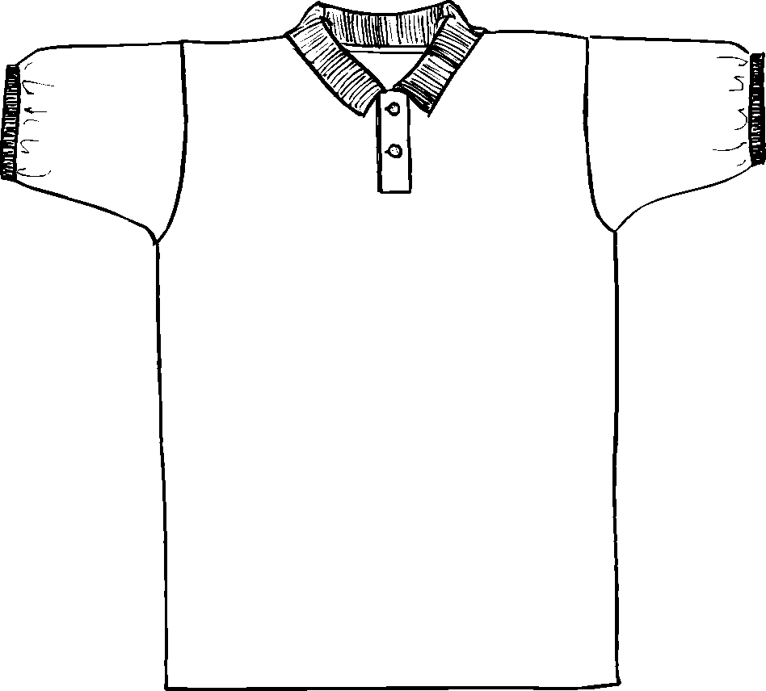

Descriptions
*50/50 Poly combed cotton blend, 5.6 ounce
*Ring spun yarn
*Welt collar & rib knit cuffs
*Wood tone buttons
*Double needle bottom hem
*Embroidery & screen printing okay

Finished Garment Measurements

Size | S | M | L | XL | 2XL | 3XL
Width | 20 | 21.50 | 23.75 | 26.25 | 28.50 | 31
Length | 28 | 29 | 30 | 31 | 32 | 33
Armhole | 10 | 10.50 | 11 | 11.50 | 12 | 12.5
Sleeve Length | 17 | 18.50 | 20 | 21 | 22 | 23

